Jefferson Hills EAC Meeting Minutes, June 23, 2021

- Role call was captured by zoom participation, all EAC Members present except R. Moore

  - Tom welcomed the ACHD to the meeting
    - Attending from ACHD:
    - Dean DeLuca - Program Director
    - Shannon Sandburg - Quality & Compliance
    - David Good - Monitoring
    - Katherine Kim - Americorps volunteer

- ACHD shared a powerpoint presentation based on the questions provided to them prior to the meeting concerning Air Quality concerns in the region with a focus on the U.S. Steel Clairton Coke Plant

- Phases of Air Quality: Monitoring (where are the issues); Planning (how to fix non-compliance); Permitting (for sources within the county); Enforce (use permitting requirements) (continuous cycle that reacts to changing regulatory requirements - EPA etc).
- Overview of air quality stations - measures regulatory (PM2.5, PM10) and non-regulatory (air toxics such as volatile organic compounds, carbon, and odor surveillance)
- Three ozone monitoring sites
  - SiO2 measured at Liberty and N. Braddock (near Jefferson)
  - NiOx measured at three locations

- Temporary sites for comprehensive studies, including Mon Valley to monitor volatile organic compounds (next 15-18 months)

- Total of 28 geographic monitoring sites across the county

- Quality Assurance project plan + SOP
- Air monitoring station is constructed and cited with EPA regs
- Measure air concentrations (finite sample over 24 hours or continuously)
- QA and QC procedures to validate data at ACHD
- Data is used by EPA, inhouse by the ACHD planning section, or epidemiology division

Questions:

- PM2.5 is measured 3 ways
  - Federal reference method (FRM)
  - Federal equivalent method (FEM)
  - Chemical speciation monitor (capture and identifies different chemical species)
  - FRM primary at 6/8 sites
  - FEM primary at 2/8 sites
    - At Liberty and Lawrenceville Chemical Speciation Monitoring: manual, filter-based
    - Monitored at Liberty (downwind of USS Clairton), Clairton (upwind of USS Clairton), North Braddock (downwind of USS Edgar Thompson) [note: dominant wind direction is west to east]. Former monitoring sites include South Part and Elizabeth Forward (not much detected)

- Monitoring shelters are kept within rigid temperature, humidity and particulate ranges to ensure function and quality of data capture
Recalibrates each evening with a test gas sample to validate the analyzer (QA & QP)
Compared to national ambient air quality and used by EPA to inform regulatory policy
Third party audits every other year
- Automated continuous gas monitors
24/7 automation, 3rd party audits, legally-defensible environmental data

- Air Toxics Monitoring Allegheny County
Recently joined the air toxics control network – good comparison to non-source oriented locations

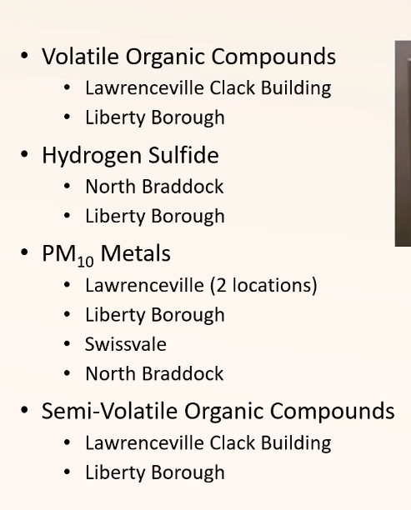

- Hydrogen sulfide moved to North Braddock from Avalon site after closing of the coke plant as the levels dropped significantly
- North Park eliminated based on low uniform readings
- Liberty, North Braddock, Clairton are Mon Valley monitoring sites
- Liberty is downwind site from US Steel and Clairton is upwind site
- Liberty PM2.5 - 11.1 (2018-2020)
- Clairton PM2.5 - 8.0 (2018- 2020)
- Topography, mobile, industrial, transport sources of PM2.5, surface inversion all affect PM2.5 levels
- Highest impact downwind of the US Clairton Coke Works
- Liberty monitoring 24 hr max (2018-2020) = 50.4
- Contribution from each site is estimated through meteorological and emissions data modeling of air dispersions
- Chemical Speciation surveillance - third party lab validates
  - Liberty is outlier - carbon and chlorine rich (hydrochloric acid) PM2.5
- Air dispersion modeling contours include contributions from all sources and show extent of predicted maximum PM2.5 in the MonValley for 2021, with contributions from all sources:
  - Yellow -moderate
  - Orange - unhealthy for sensitive populations
  - Red - unhealthy

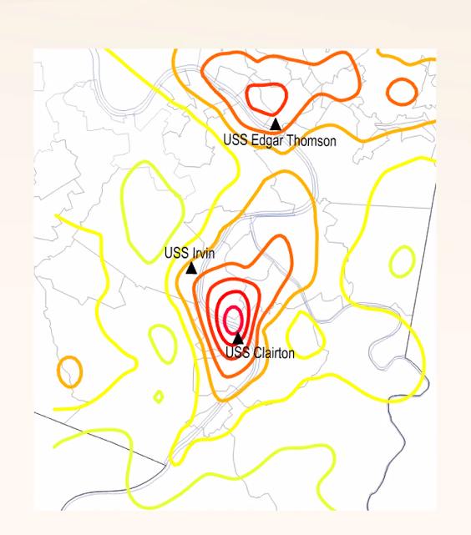 PM_{2.5} monitoring observations
National Ambient Air Quality Standards: PM_{2.5} is calculated as a 3 year annual average, with 12.0 µg/m³ for the 2018 – 2020 data set
South Fayette monitor (considered a background): 7.4 µg/m³
Mon Valley: Highest PM_{2.5} impact is downwind of Clairton Coke Works (CCW)
      - 24-hour concentrations are highest downwind of CCW compared to “background” sites – the 24-hour concentrations are dependent on meteorological conditions
      - PM_{2.5} at the Liberty monitor is carbon-rich industrial (carbon non-wood burning) and chlorine-rich industrial (from hydrochloric acid); motor vehicles are not a significant contributor at this site. Otherwise, the remaining Liberty PM_{2.5} has similar sources as PM_{2.5} detected at the Lawrenceville, Burgettstown, and Greensburg stations.

    - DEP makes the forecasting determination and notifies ACHD to send alerts to municipalities and schools (Code Orange)
  - Permitting practices
  - All new sources subject to Best Available Technology requirements

- Monitoring Emissions during Coke Production
  - Basic process of coke production: Coal is cooked to develop coke, it is “charged” to battery ovens. After coal is cooked in battery ovens, and after pressure relief through suctioning off-gases, the doors of the ovens are removed, the coke is pushed out into a rail quench car and car transports coke to a quench tower.
  - Inspectors at the top of the battery will record emissions during charging. Opacity is the percent of material blocked by smoke at the record point based on the standard by the inspector.
    - Soaking: Opacity readings of emissions from stand pipe
    - Pushing: Opacity readings of emissions during daylight hours – monitoring during traveling, topside lids, topside offtakes, door leaks
  - Inspectors include: ACHD and 3rd party independent (through request for bid by ACHD, paid for with USS funds); USS. There have been 50,000 inspections since the 2019 agreement went into effect.
- Allegheny County Health Department (ACHD) and US Steel (USS) 2019 Consent Agreement
  - USS Clairtion Coke Plant is compliant with terms of the 2019 agreement (See compliance timeline chart at end of these minutes). The agreement has stipulated penalties, which are summarized quarterly. USS enacted dispute resolution portions of the agreement for the coke oven regulations. USS was in compliance with the 2019 agreement terms.
  - The ACHD has a source testing manual to define inspection methods. Recently they proposed revised coke oven regulations to primarily clarify procedures and include them in regulations, which is separate from the 2019 agreement with USS.
  - The first quarter of the settlement agreement was during Q2 of 2019. This was delayed until Q1 of 2021 due to issues coming back online after Covid.
  - Automated opacity monitors are included in the CCW stacks, and penalties are based on a certain percentage of the opacity. Any violations are measured in clock hours, and were lower between 2020 and 2021 compared to prior to the 2019 agreement
  - USS applied for permits to modernize the Mon Valley plants but then withdrew the applications. They needed to meet the Best Available Control Technology but ACHD couldn’t require them to install the BACT unless there was a consent agreement.
  - USS announced that they plan to shut down the 3 oldest coke batteries by Q1 of 2023, which will result in emissions reductions. This action is part of the 2019 Consent Agreement to install new baghouses or reduce emissions in an equivalent method.
  - Inspections and emissions data help show USS and ACHD what needs to be repaired. USS will sometimes conduct significant repairs themselves, and other times repairs become required through ACHD enforcement actions.
- ACHD and Pennsylvania Department of Environmental Protection (PA DEP)
  - Under the Federal Clean Air Act, the Federal Environmental Protection Agency has oversight over the ACHD and PA DEP.
  - Each state determines how to meet Federal Clean Air Act standards.
  - ACHD has authority to enforce regulations from non-mobile sources in Allegheny County. ACHD and PA DEP coordinate on topics which cross county lines, and PA DEP takes the lead on multi-county issues involving Allegheny County.
- Questions from the Environmental Advisory Council:
  - What is the stringency of the regulation? Are there ACHD regulations on top of the EPA regulations?
Answer from ACHD: The Federal standard was defined 30 – 40 years ago, involving 30 day rolling averages. Locally, the ACHD is focused more on instantaneous standards to highlight non-compliance on specific days, resulting in more stringent requirements.
  - How does the ACHD deal with inaccuracies presented to the press, such as issues pushed by both industry and environmental groups, on regional air quality issues?
Answer from ACHD: The goal is to provide more public information related to enforcement actions, compliance evaluations of Title 5 sources posted. There are sometimes an inconsistency between reported monitoring information and perceptions of USS CCW compliance. Environmental performance and emissions may not always match.
  - How can Jefferson Hills Borough become involved with understanding regional issues surrounding air quality?
Answer from ACHD: Various subcommittee groups exist across Allegheny County (anyone can participate, ask questions/comment, and meetings are virtual). The Air Quality alerts and dashboard are available. There also is a complaint line and website for direct reporting of air quality concerns/violations, and these go to an inspector for review.
Subcommittee groups include: Criteria Pollutant and Monitoring; Air Quality Pollutant & Education; Air Advisory
The Local Government Academy can help disseminate knowledge – they keep information on the ACHD on record, and have a pre-recorded webinar
Public hearings for permits

Notes on Other Business for the Jefferson Hills Borough Environmental Advisory Council:
- Walkworks application was submitted. The Walkworks Grant, if approved for the Borough, would work well with the Borough’s work in updating the Comprehensive Plan. The Comprehensive Plan will focus on the question of “where do you want to be in the next 10 years?” and planning will begin in August/September 2021. Environmental items are one consideration, along with the Active Transportation Plan, Recreation, Land Use (connect with John Stinner to identify interest). There is a Request for Proposals for a new Municipal Planner, to be awarded sometime in August.
- USS/Air Quality: Kevin Polick is part of the USS Community Board, and is planning to discuss the potential to Adopt a Road with USS.
- The Beedle Park grant application is in progress. TJ Youth Soccer is interested in the plans, and the Borough is engaging with youth football on developing a master plan. Items to consider for the EAC include the safety of roads, along with an extension of the DCNR grant funding. There may be a potential to include an environmental interpretive trail, depending on long-term planning.
- Peters Creek Road Adoption: Karen Bucy can help with questions on security and protection. The Borough has vests, cones, and bags for any group wanting to help clean up a stretch of road. Rick Moore for the Boy Scouts and Kevin Polick with USS Clairton Plant have expressed interest.
- Abandoned Drums: John Stinner is going to follow up with Richard Moore on next steps.
- Subsurface Mapping of Jefferson Hills: There is a need to access data/maps for underground mines from the PA DEP. Need to meet with the DEP and Gateway to identify what it would cost to add subsurface maps to the Gateway system.
- Transport of Drilling Waters: Wastewater from oil and gas wells is proposed to be transported on barges along the rivers. One barge can transport the equivalent of 57 tanker trucks. The water is directly from oil-gas separators at wellheads and is being transported for treatment. There is an opportunity for the Borough to ask questions about safety issues – what are the risks in transporting oil and gas wastewater over land versus water? What is the plan if something happens in any scenario? Terry to follow up.
- Additional Questions for ACHD/Others:
  - Perfluorocarbon “forever” chemicals – are they being tested for in our municipality?
  - Hemp plastic?
  - What is happening with the Cheswick coal-fired power plant? (Complete shutdown is planned)
  - Power generation plant in Elizabeth/Boston area?
- General Business
  - Hybrid meeting is possible
  - For meetings with lots of presentations – Zoom would be useful for slide sharing
  - Voted: Passed to have hybrid open for EAC members if necessary, with meeting in the Borough building (public invited to in-person meeting)
- Next EAC meeting is scheduled for September 22nd in Council Chambers
- Advertising of meeting
  - Group approval of information to be advertised/communicated
  - Voted: All present voted to OK this
- Publish minutes on Borough website
  - All voted OK
  - Send minutes to Gracie gduda@jeffersonhills.net
- No meeting over the summer

US Steel’s Clairton Plant Compliance Chart with June, 2019 Consent Agreement with the Allegheny County Health Department.

